SIMATS ENGINEERING

ASSESSMENT TOOL 2

COURSE NAME: Artificial Intelligence COURSE CODE: CSA17

COURSE OUTCOME COVERED
CO5: Design AI-based systems using PySpark, RDD operations, and intelligent agent architectures, using scalable systems and integrate components in distributed AI applications. (BTL 5)
Assessment Tool Weightage: 50%

Duration : 1 Hour
QUESTIONS: 5 Total Marks:50

Annexure A

Technical Presentation

Code of Conduct:

I S.SHAMAH ALI FATHIMA(192573002) (Name / Reg No) certify that this submission is my original work and that I have adhered
to the guidelines specified for this assessment.
I understand that any violation of academic integrity rules will result in disciplinary action.

Signature of the student:
Shamah

Annexure A

Technical Presentation
- Reactive Agent-Based Traffic Control System

Prepare a technical presentation on designing a Reactive Agent for a smart traffic control system. Explain how the agent responds to real-time traffic inputs, manages signal changes, and ensures minimal congestion using streaming data processing.
- Goal-Based Agent for Healthcare Diagnosis

Develop a presentation on a Goal-Based Agent used in an AI healthcare system. Describe how the agent sets diagnostic goals, evaluates patient data, and selects optimal treatment pathways using decision-making logic and data pipelines.
- Utility-Based Agent for E-Commerce Recommendations

Create a technical presentation on a Utility-Based Agent that generates personalized product recommendations. Explain how the agent assigns utility values to different options and optimizes user satisfaction using large-scale data processing.
- Learning Agent for Personalized Education System

Present the design of a Learning Agent in an AI-driven educational platform. Explain how the agent improves performance over time using feedback, adapts content difficulty, and integrates with distributed data processing systems like PySpark.
- Multi-Agent System for Disaster Management

Prepare a presentation on a Multi-Agent System where multiple agents (sensor agents, decision agents, communication agents) collaborate for disaster detection and response. Explain coordination strategies, data sharing, and real-time decision-making.

RUBRICS FOR CALCULATION

Criteria | Weightag e | Level 4 – Exemplary | Level 3 – Proficient | Level 2 – Developing | Level 1 – Beginning
Technical Content Accuracy | 30 | Highly accurate, in-depth, and insightful technical explanation | Technically correct content with adequate depth and clarity | Basic concepts presented with limited accuracy and depth | Content contains major technical errors; concepts poorly understood
Problem Identification | 25 | Problem rigorously analyzed using appropriate and advanced  methods | Problem clearly defined with a logical engineering approach | Problem identified but analysis or methodology is weak | Problem statement unclear or incorrect; no logical approach
Use of Tools | 20 | Advanced tools, well-analyzed data, and highly effective visuals | Appropriate tools and data used effectively with clear visuals | Limited use of tools and basic data interpretation | Minimal or incorrect use of tools and data; poor visuals
Communicatio n | 15 | Highly engaging, confident, and audience-focused delivery | Clear, organized, and professional communication | Understandable but lacks clarity, structure, or confidence | Poor organization, unclear speech, ineffective slides
Professionalis m | 10 | Exemplary professionalism, leadership, and ethical awareness | Professional conduct with effective team collaboration | Basic professionalism; uneven team participation | Lacks professionalism; minimal contribution or  ethical awareness

Goal based health care diagonasis system
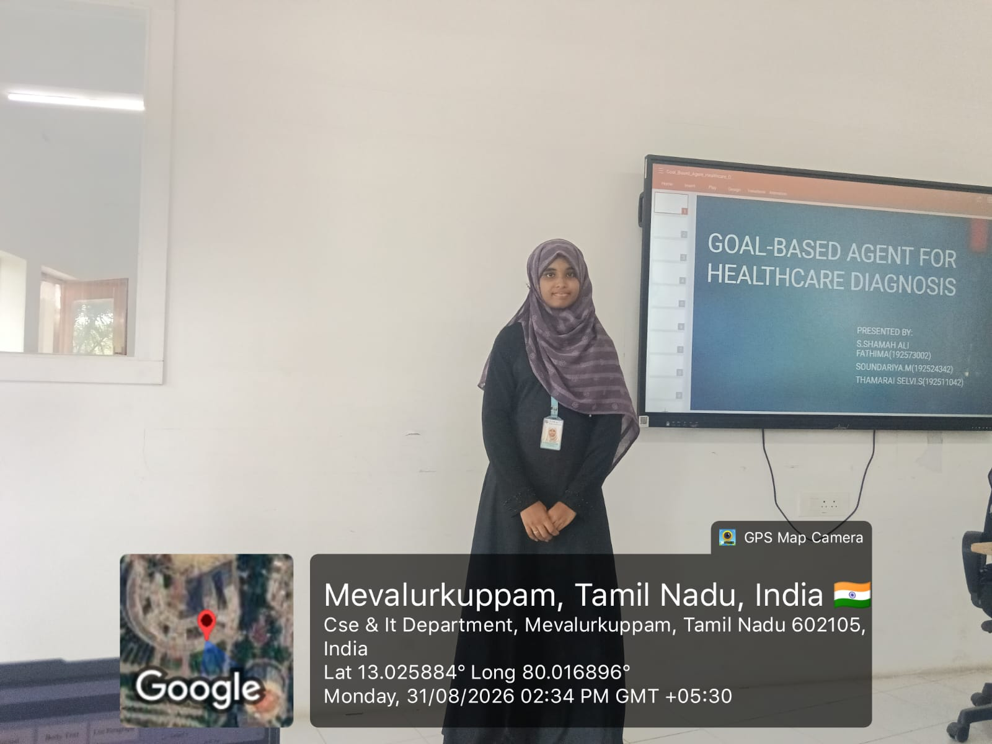

Introduction
A Goal-Based Health Care Diagnosis System is an intelligent healthcare system designed to identify possible diseases and provide suitable diagnostic suggestions based on patient symptoms, medical history, and health conditions. The system focuses on achieving specific healthcare goals, such as early disease detection, accurate diagnosis, and improved patient care. By using technologies like Artificial Intelligence, machine learning, and rule-based algorithms, the system can support doctors and patients in making better healthcare decisions. It helps improve the speed, accuracy, and efficiency of the diagnosis process.
Key Points
- Identifies possible diseases based on patient symptoms.
- Analyzes medical history and health conditions.
- Supports early disease detection and prevention.
- Helps in achieving specific healthcare goals.
- Provides quick and accurate diagnostic suggestions.
- Uses AI, machine learning, or rule-based algorithms.
- Supports doctors in better decision-making.
- Improves the quality and efficiency of healthcare services.

